Downloading...
From: https://drive.google.com/uc?id=1VJaDVtDUtKQMmhRAqr3t-fgng899ZdRV
To: /content/Python Application Usage Log Data Set.xlsx
100%|██████████| 1.68M/1.68M [00:00<00:00, 79.9MB/s]
/usr/local/lib/python3.12/dist-packages/statsmodels/stats/outliers_influence.py:197: RuntimeWarning: divide by zero encountered in scalar divide
vif = 1. / (1. - r_squared_i)
[VIF] Dropped 'is_weekend' (VIF=inf). Remaining cols: 46
ADF Statistic: -9.6707, p-value: 0.0000
Any object dtypes in X? -> False
Remaining NaNs in X? -> 0
X columns used: 18
Checked order (0, 1, 0) x (0, 1, 0, 7), AIC=77821.95, LB p10=0.000, p20=0.000
Checked order (0, 1, 1) x (0, 1, 0, 7), AIC=77225.53, LB p10=0.000, p20=0.000
Checked order (1, 1, 0) x (0, 1, 0, 7), AIC=77450.78, LB p10=0.000, p20=0.000
Checked order (1, 1, 1) x (0, 1, 0, 7), AIC=76714.24, LB p10=0.000, p20=0.000

Selected by AIC (no full LB pass): order=(1, 1, 1), seasonal=(0, 1, 0, 7), AIC=76714.24

SARIMAX Results
==========================================================================================
Dep. Variable: daily_active_users No. Observations: 4631
Model: SARIMAX(1, 1, 1)x(0, 1, [], 7) Log Likelihood -38354.118
Date: Fri, 14 Nov 2025 AIC 76714.236
Time: 05:09:39 BIC 76733.551
Sample: 08-01-2012 HQIC 76721.033
- 04-05-2025
Covariance Type: oim
==============================================================================
coef std err z P>|z| [0.025 0.975]
------------------------------------------------------------------------------
ar.L1 0.5620 0.014 41.516 0.000 0.535 0.589
ma.L1 -0.9999 0.036 -28.119 0.000 -1.070 -0.930
sigma2 1.073e+06 4.03e+04 26.606 0.000 9.94e+05 1.15e+06
===================================================================================
Ljung-Box (L1) (Q): 8.49 Jarque-Bera (JB): 1180950.20
Prob(Q): 0.00 Prob(JB): 0.00
Heteroskedasticity (H): 1.08 Skew: 0.05
Prob(H) (two-sided): 0.15 Kurtosis: 81.32
===================================================================================

Warnings:
[1] Covariance matrix calculated using the observed information matrix (complex-step) described in Harvey (1989).
Test MAE: 686.786
Test RMSE: 873.892
Test MAPE: 47.84%
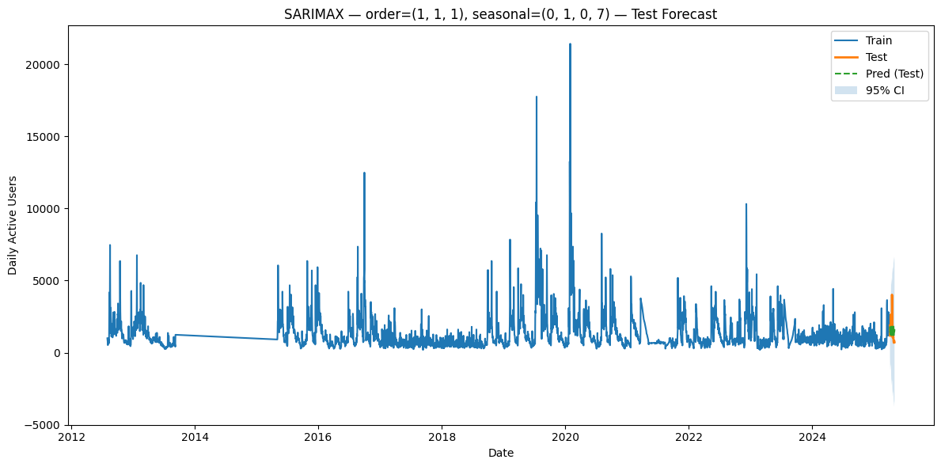

------------------------------------------------------------------------------------------

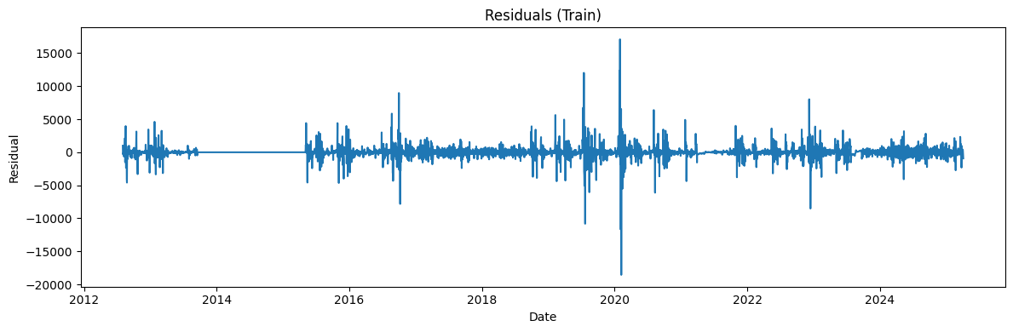

------------------------------------------------------------------------------------------

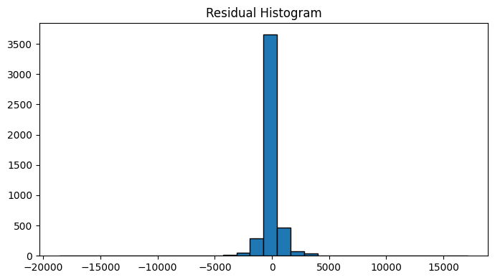
Ljung-Box stats & p-values (train):
lb_stat lb_pvalue
10 1344.923531 7.702155e-283
20 1382.229065 7.155560e-281

------------------------------------------------------------------------------------------

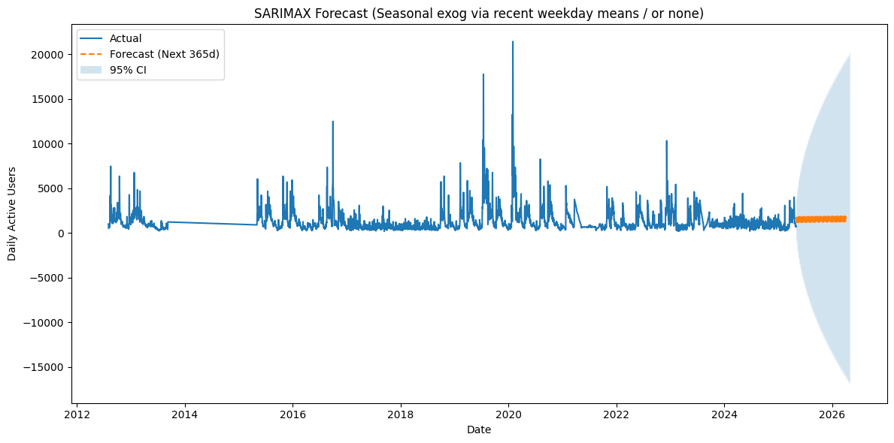

Accuracy (100 - MAPE): 52.16%
MAPE: 47.84% sMAPE: 42.29%
MAE: 686.786 RMSE: 873.892 R²: -0.034
MASE (vs naive-1): 2.113
Directional Accuracy: 53.57%

